**SQL QUERIES**

**CREATING TABLES: -**

**User Table**

CREATE TABLE users (

user_id INT AUTO_INCREMENT PRIMARY KEY, email VARCHAR(255) UNIQUE NOT NULL, password VARCHAR(255) NOT NULL,

role ENUM('admin', 'user') DEFAULT 'user’ NOT NULL

);

**Expenses Table**

CREATE TABLE expenses (

expense_id INT AUTO_INCREMENT PRIMARY KEY,

user_id INT,

amount DECIMAL(10, 2), category VARCHAR(50), date DATE,

description VARCHAR(255),

FOREIGN KEY (user_id) REFERENCES users(user_id) ON DELETE CASCADE

);

**BUDGET Table**

CREATE TABLE budgets (

budget_id INT AUTO_INCREMENT PRIMARY KEY,

user_id INT,

budget_amount DECIMAL(10, 2),

period VARCHAR(20), -- 'weekly' or 'monthly' start_date DATE,

end_date DATE,

FOREIGN KEY (user_id) REFERENCES users(user_id) ON DELETE CASCADE

);

**INSERT STATEMENT**

**User**

INSERT INTO users (user_id, email,password) VALUES (1, 'Alice Smith', 'alice@example.com'),

(2, 'Bob Johnson', 'bob@example.com'),

(3, 'Carol Williams', 'carol@example.com'); INSERT INTO users (email, password, role)

VALUES ('sidhvinuvvula16@gmail.com', 'Sidhu@1416', 'admin'); SELECT * FROM USERS;

**Expenses**

INSERT INTO expenses (expense_id, user_id, date, amount, category, description) VALUES

(1, 1, '2024-10-31', 32.97, 'Entertainment', 'Sample expense data'),

(2, 2, '2024-10-24', 121.75, 'Dining Out', 'Sample expense data'),

(3, 2, '2024-10-25', 50.67, 'Entertainment', 'Sample expense data'),

(4, 1, '2024-11-08', 61.04, 'Utilities', 'Sample expense data'),

(5, 3, '2024-11-09', 141.26, 'Dining Out', 'Sample expense data');

SELECT * FROM expenses;

**Budgets**

INSERT INTO budgets (budget_id, user_id, budget_amount, period, start_date, end_date)

VALUES

(1, 1, 794.45, 'weekly', '2024-10-13', '2024-11-12'),

(2, 3, 425.87, 'weekly', '2024-10-13', '2024-11-12'),

(3, 2, 890.11, 'monthly', '2024-10-13', '2024-11-12'),

(4, 3, 339.07, 'monthly', '2024-10-13', '2024-11-12'),

(5, 3, 224.22, 'weekly', '2024-10-13','2024-11-12');

SELECT * FROM budgets;

SELECT * FROM users

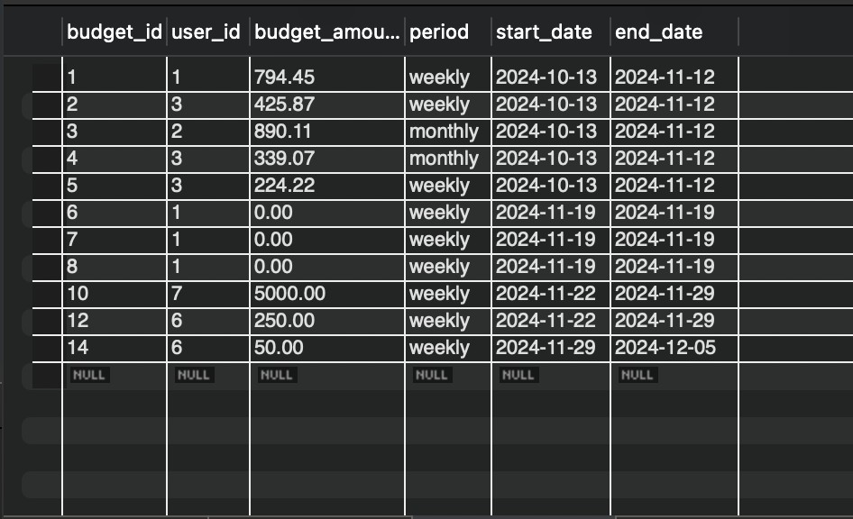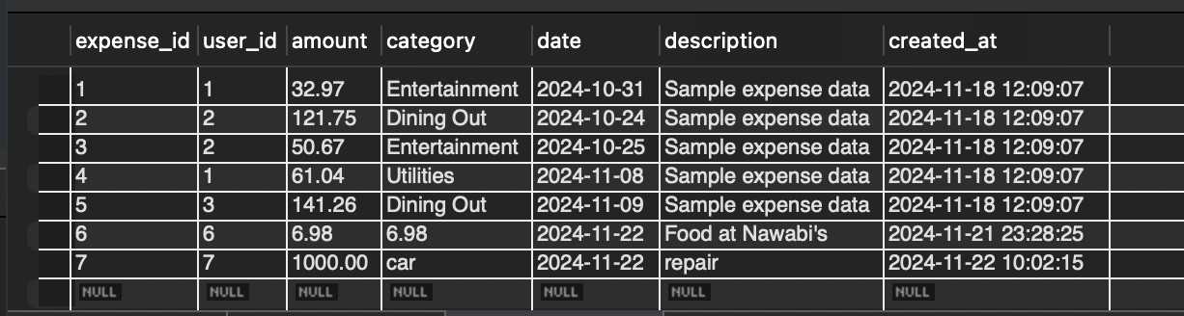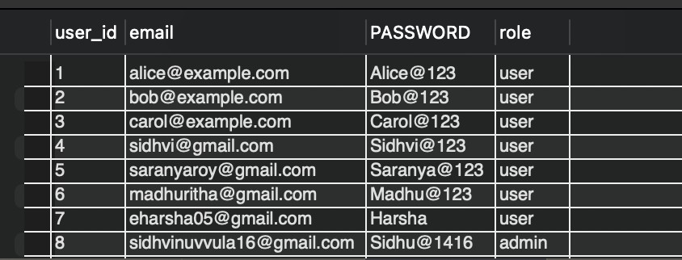

SELECT * FROM expenses

SELECT * FROM budget